PRACTICAL 3: PATCH BOX INSTALLATION
Objective
Install and terminate network outlets.
Activities
- Install patch boxes.
- Terminate using T568B.
- Label outlets.
- Test connectivity.
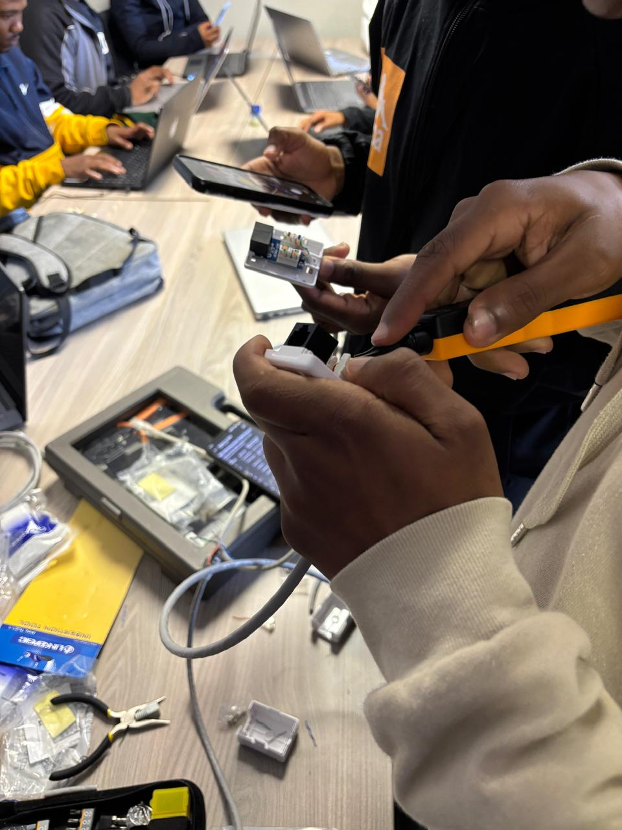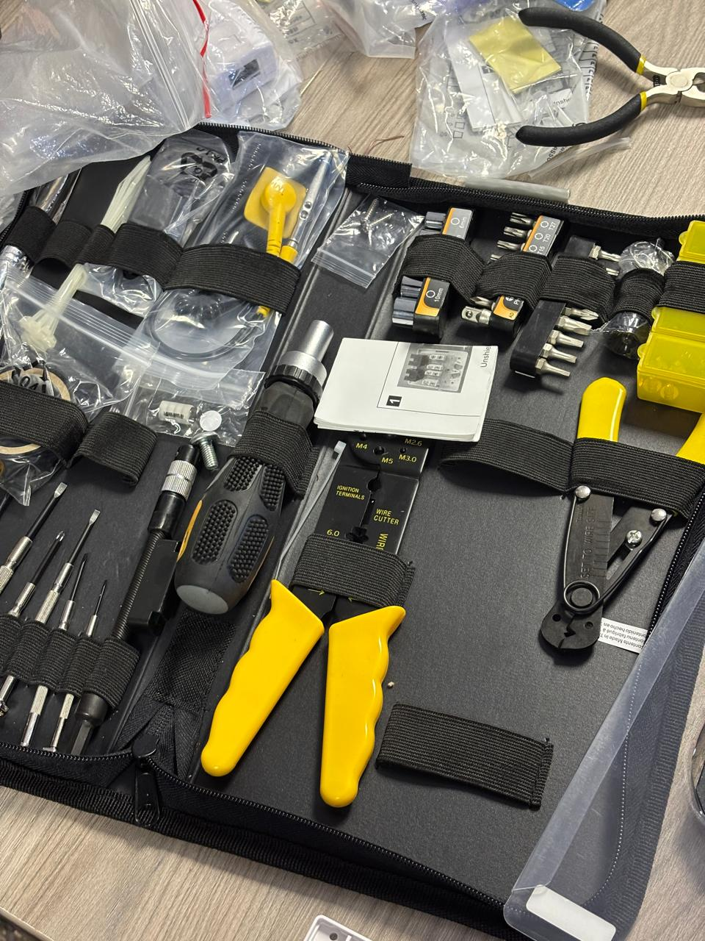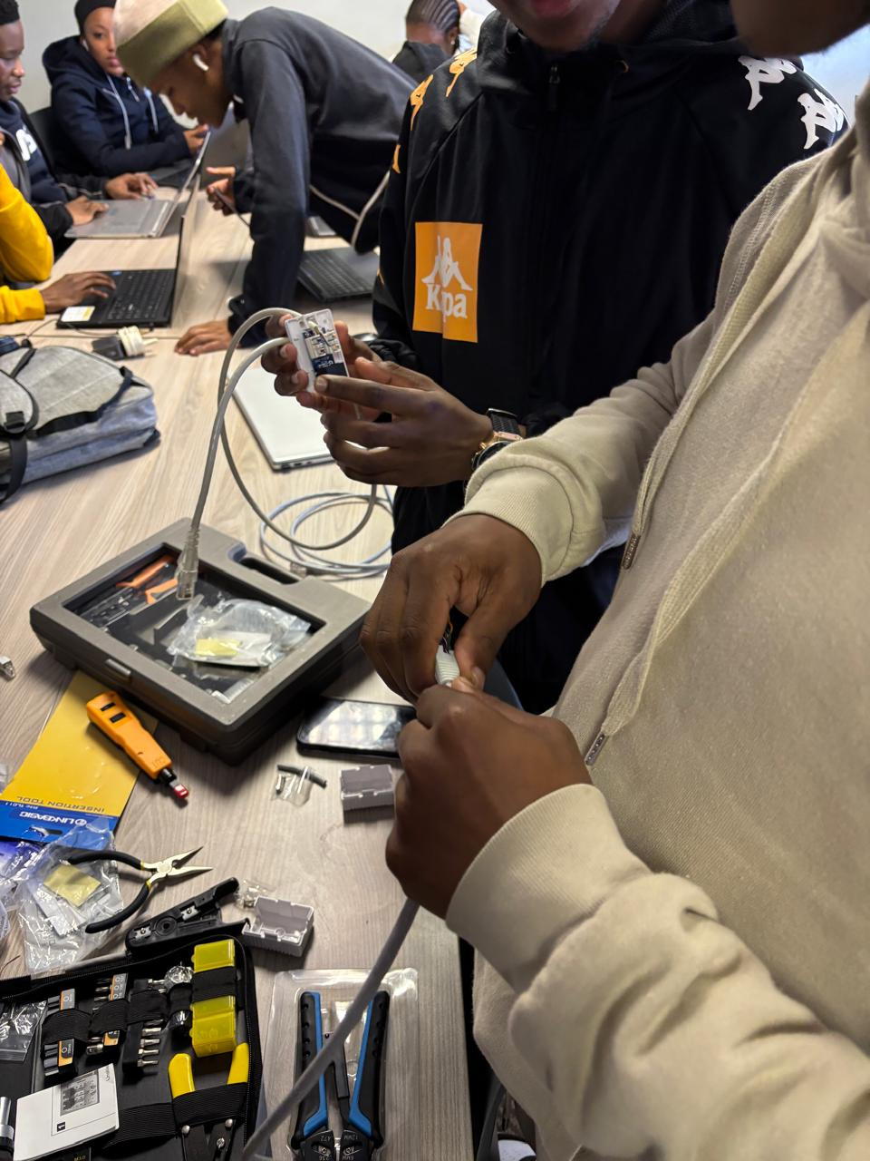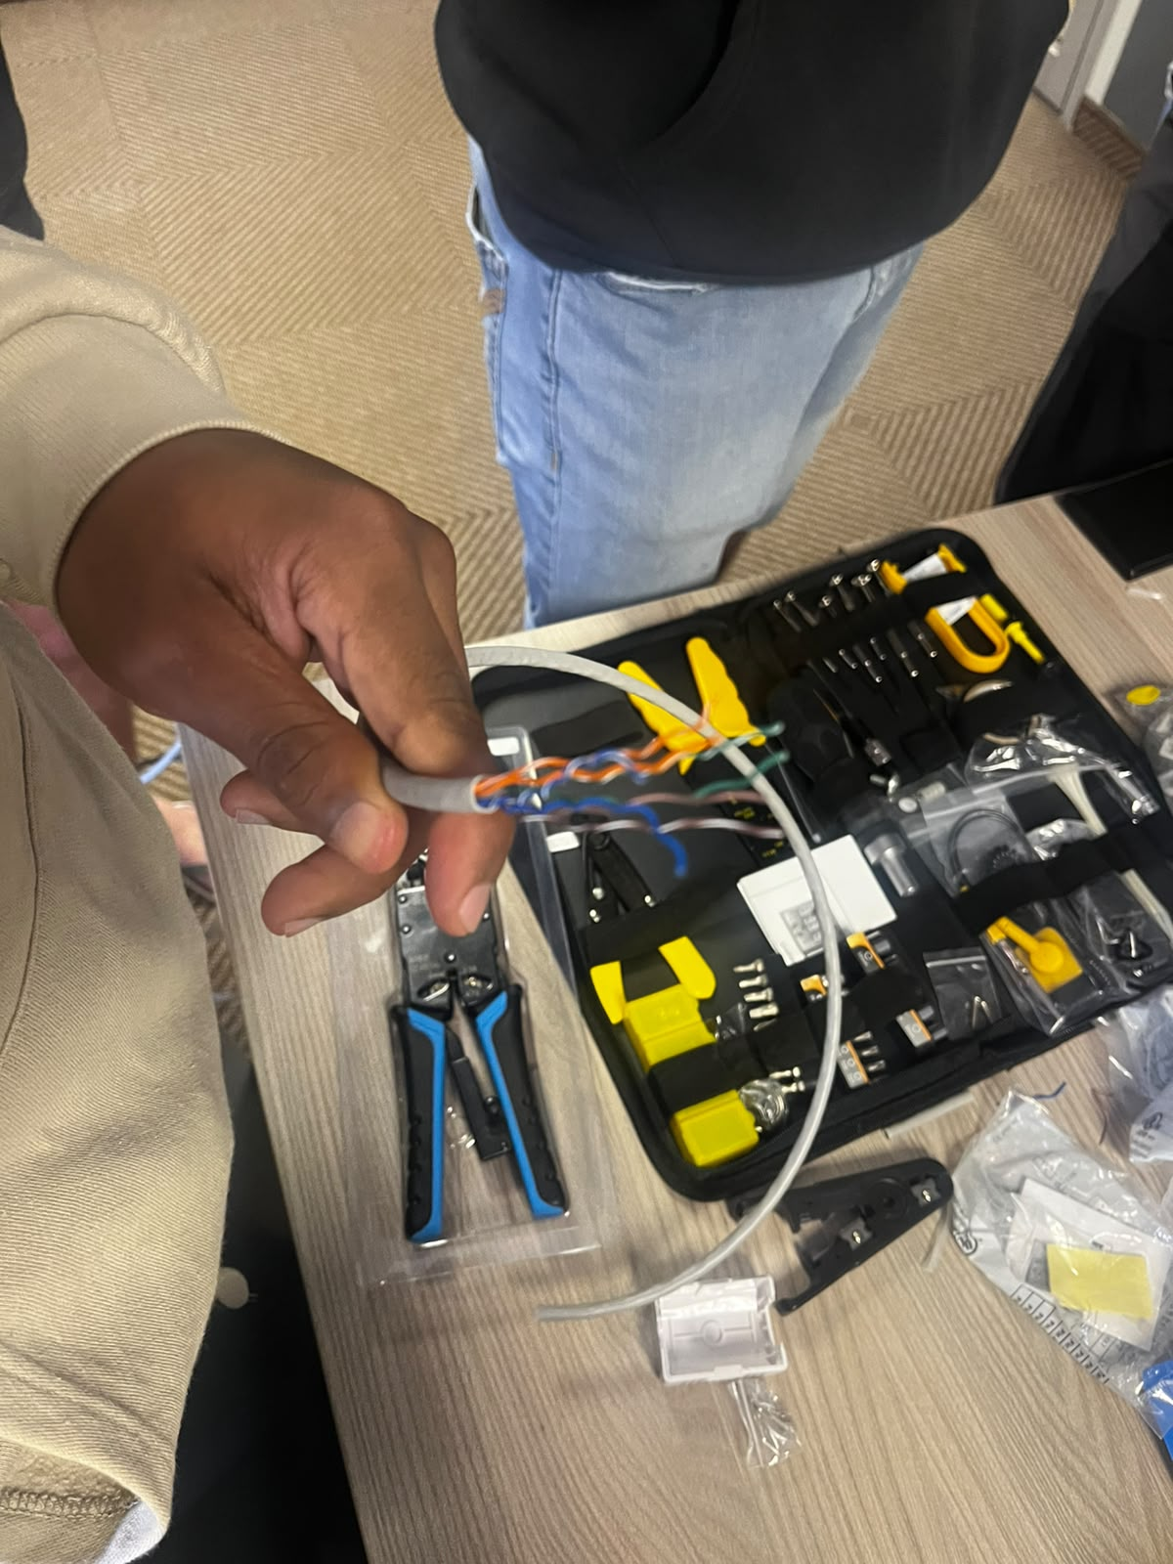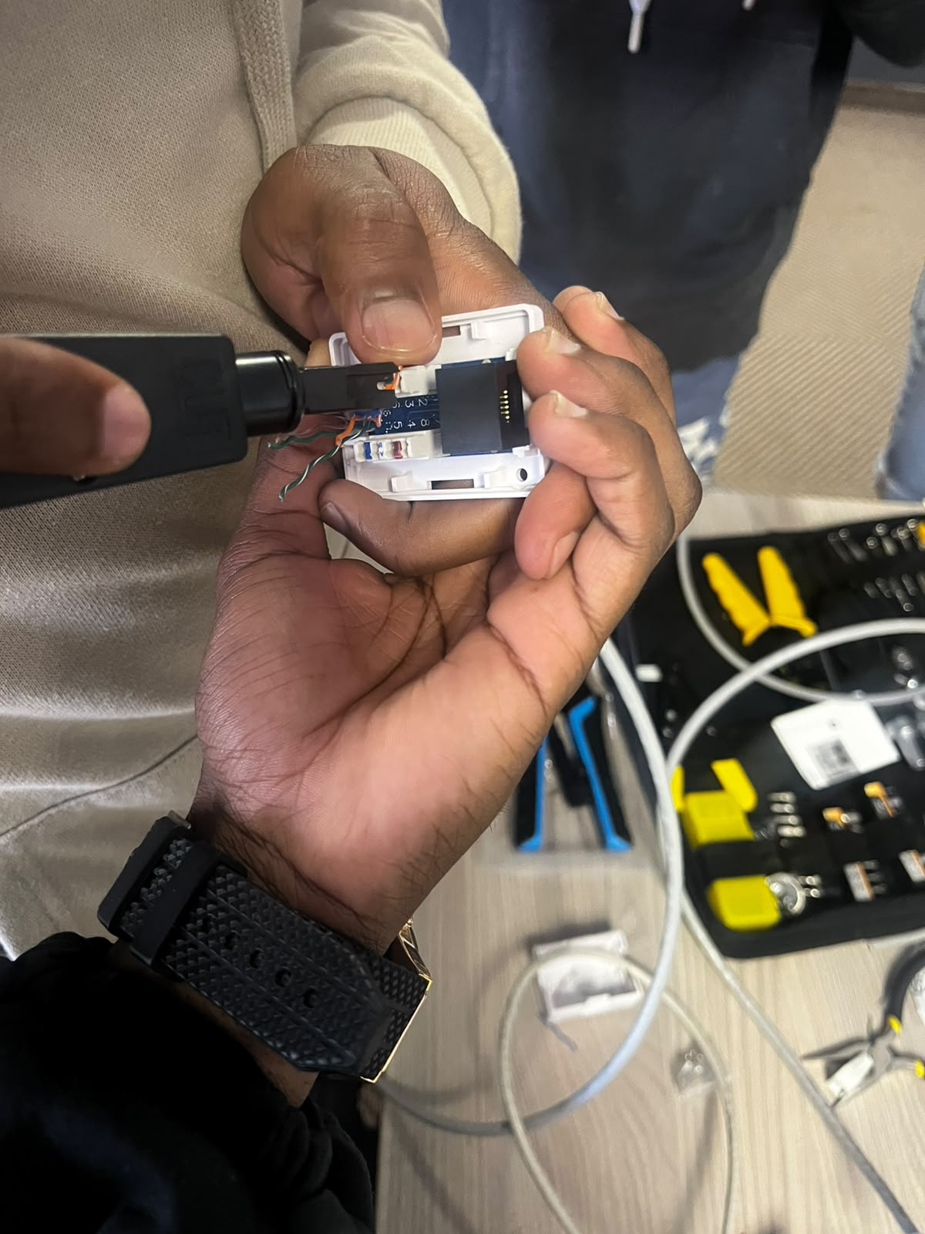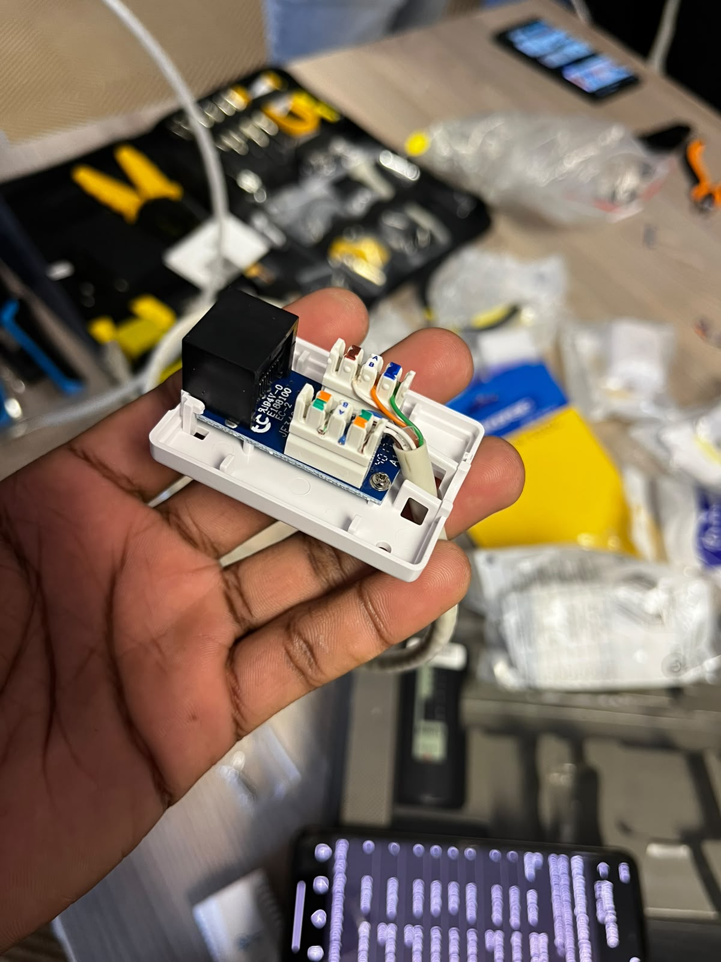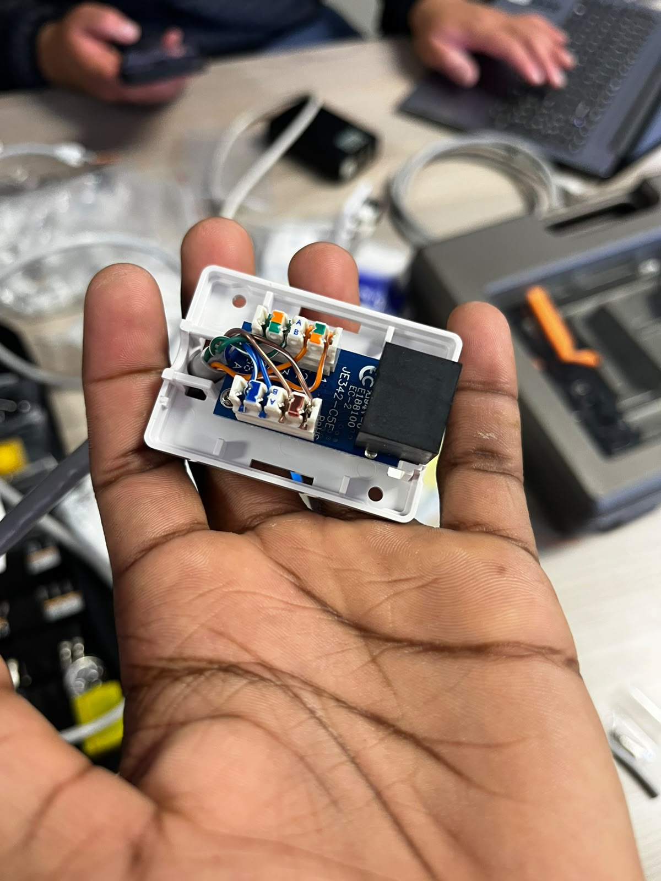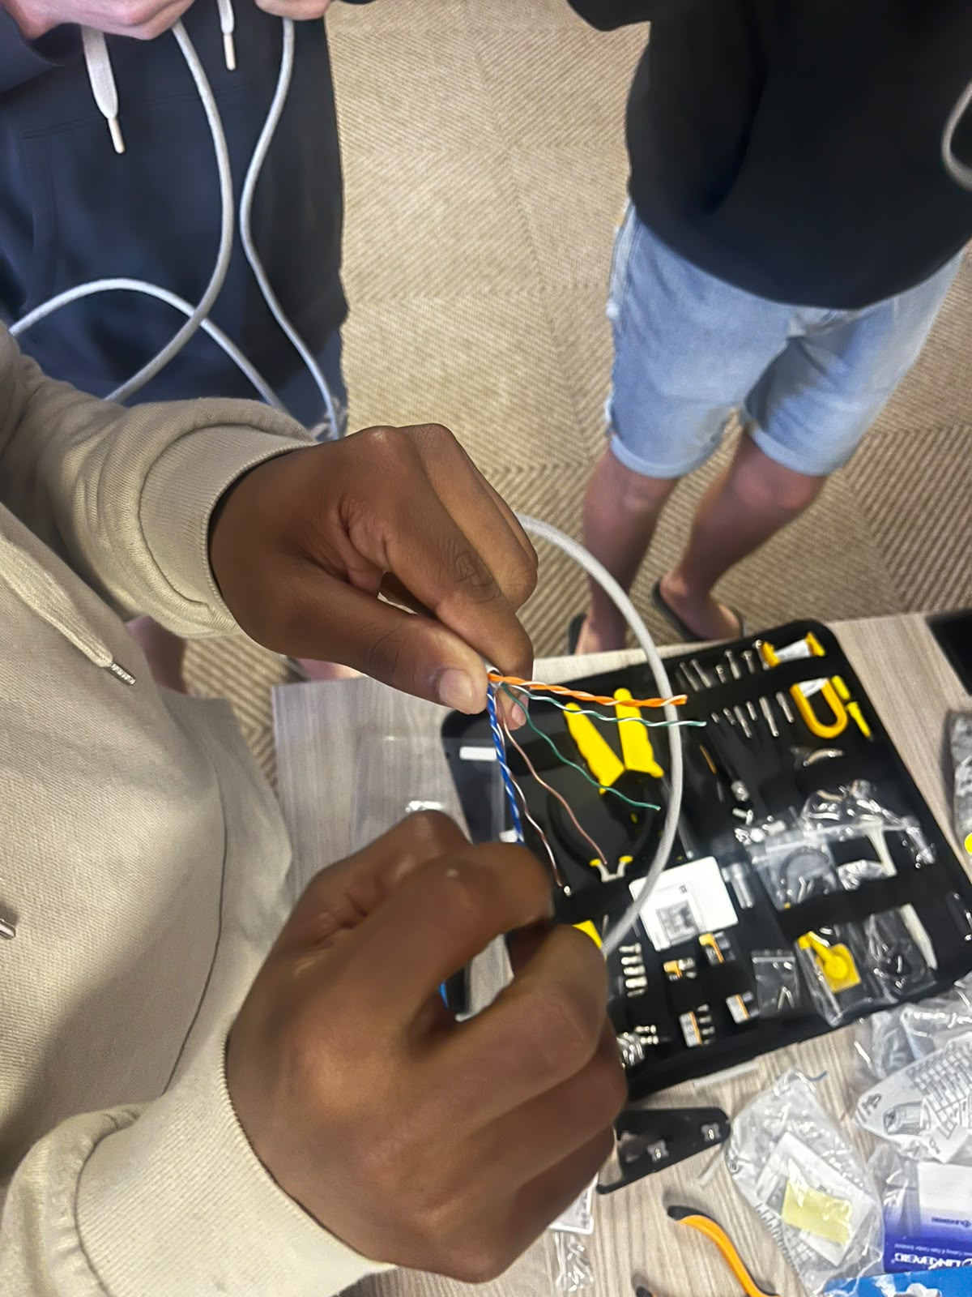
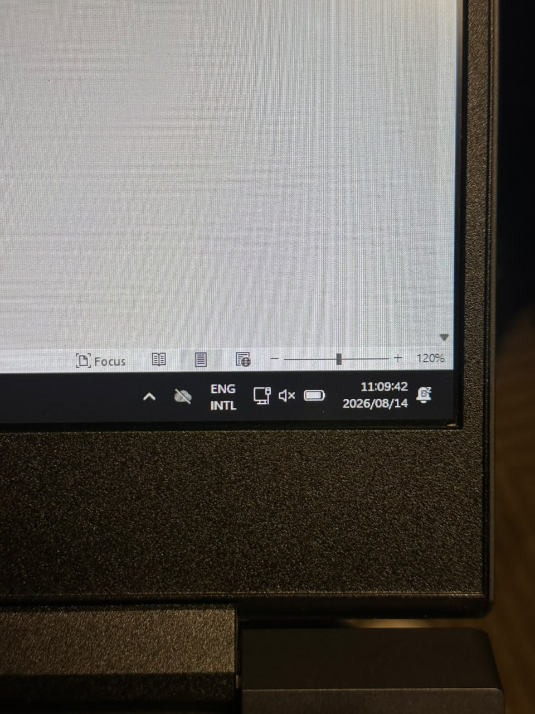
Deliverable
Fully functional network outlet.
Assessment Rubric (10 Marks) Criteria | Marks
Correct termination | 4
Use of punchdown tool | 2
Cable management | 2
Labelling | 2
Total | 10

